Singleton Pattern
You Need… | Use…
Always-on instance | Eager Singleton
Lazy init, no multithreading | Lazy Singleton
Lazy + thread safety + performance | Double-Checked Singleton
Lazy + thread safety + clean | Bill Pugh Singleton ✅
Exception handling during creation | Static Block Singleton
"lazy" in the Singleton pattern refers to delayed initialization - the Singleton instance is created only when it's first needed, rather than when the class is loaded

Singleton Implementation Approaches
1. Eager Singleton (Non-Lazy)
java
Copy
Download
public class EagerSingleton {
private static final EagerSingleton instance = new EagerSingleton();

private EagerSingleton() {}

public static EagerSingleton getInstance() {
return instance;
}
}
When to use: When you always need the instance and the creation cost is low
2. Basic Lazy Singleton (Not Thread-Safe)
java
Copy
Download
public class LazySingleton {
private static LazySingleton instance;

private LazySingleton() {}

public static LazySingleton getInstance() {
if (instance == null) {
instance = new LazySingleton();
}
return instance;
}
}
When to use: When you need lazy loading but don't care about thread safety (rare in practice)
3. Thread-Safe Lazy Singleton (Synchronized)
java
Copy
Download
public class ThreadSafeSingleton {
private static ThreadSafeSingleton instance;

private ThreadSafeSingleton() {}

public static synchronized ThreadSafeSingleton getInstance() {
if (instance == null) {
instance = new ThreadSafeSingleton();
}
return instance;
}
}
When to use: When you need thread safety but performance isn't critical (synchronization overhead)
4. Double-Checked Locking Singleton (Best Performance)
java
Copy
Download
public class DoubleCheckedSingleton {
private static volatile DoubleCheckedSingleton instance;

private DoubleCheckedSingleton() {}

public static DoubleCheckedSingleton getInstance() {
if (instance == null) {
synchronized (DoubleCheckedSingleton.class) {
if (instance == null) {
instance = new DoubleCheckedSingleton();
}
}
}
return instance;
}
}
When to use: When you need both lazy loading and high-performance thread safety
5. Bill Pugh Singleton (Most Recommended ✅)
java
Copy
Download
public class BillPughSingleton {
private BillPughSingleton() {}

private static class SingletonHelper {
private static final BillPughSingleton INSTANCE = new BillPughSingleton();
}

public static BillPughSingleton getInstance() {
return SingletonHelper.INSTANCE;
}
}
When to use: Cleanest implementation - lazy, thread-safe without synchronization, and easy to understand
6. Static Block Singleton (Exception Handling)
java
Copy
Download
public class StaticBlockSingleton {
private static StaticBlockSingleton instance;

private StaticBlockSingleton() {}

static {
try {
instance = new StaticBlockSingleton();
} catch (Exception e) {
throw new RuntimeException("Exception occurred in creating singleton instance");
}
}

public static StaticBlockSingleton getInstance() {
return instance;
}
}
When to use: When you need to handle exceptions during Singleton creation
Interview Tips
- Know the tradeoffs: Be prepared to discuss pros/cons of each approach
- Understand thread safety: Be clear on why certain implementations are thread-safe
- Modern alternatives: Mention that in dependency injection frameworks (like Spring), you often get Singleton behavior by default
- Real-world use: Be ready with examples of where Singleton is appropriate (logging, configuration, connection pools)
- Criticisms: Be aware of Singleton pattern criticisms (global state, testing difficulties)
The Bill Pugh method is generally the best answer in modern Java interviews as it combines all desirable qualities without synchronization overhead.

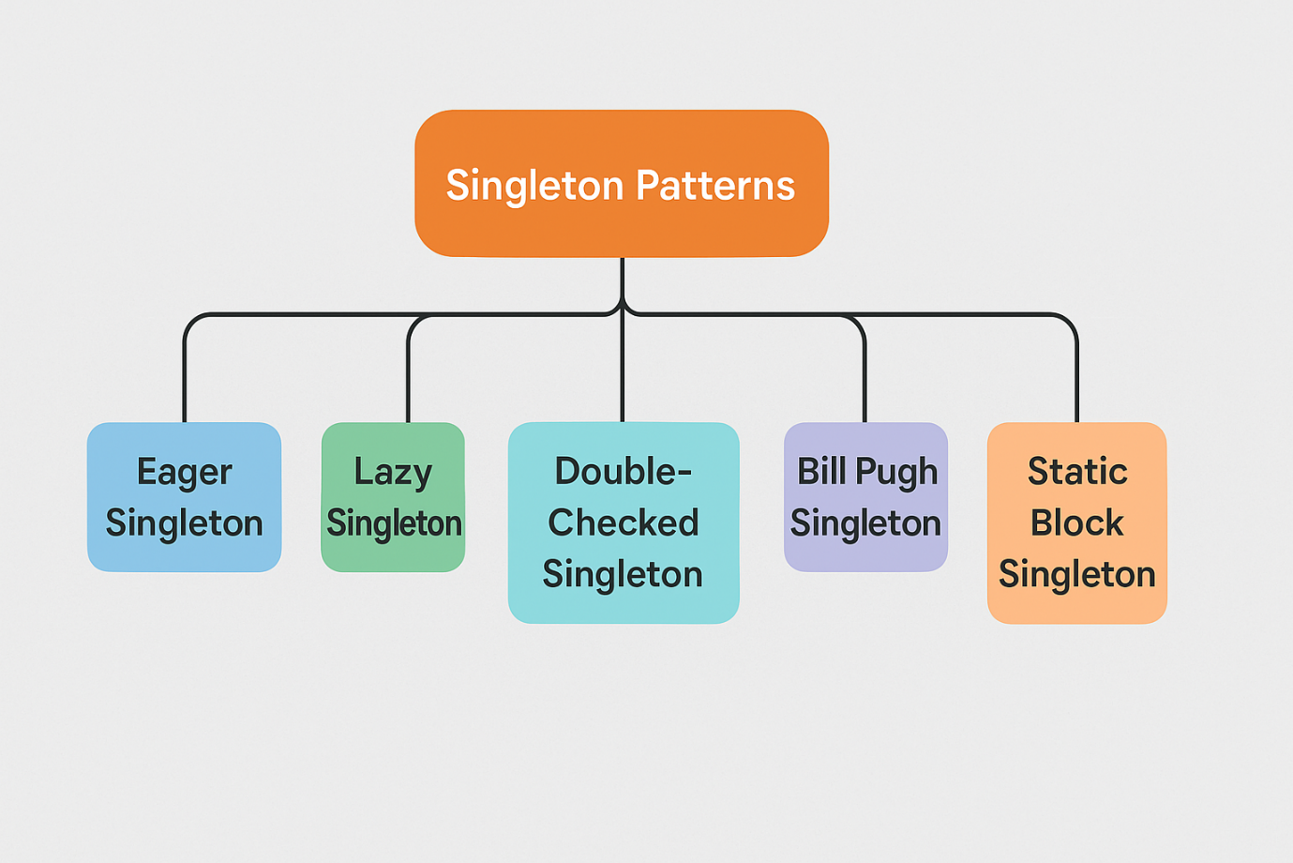

1. Where Are Static Variables Stored?
Heap vs. Method Area (Metaspace)
- Non-static (instance) variables: Stored in heap memory (each object has its own copy).
- Static variables: Stored in Metaspace (formerly PermGen) (a special JVM memory area for class metadata).
  - Why? Because they belong to the class, not individual objects.
✅ Key Point:
- Static variables live as long as the class is loaded (not tied to object lifecycle).
- They are shared across all instances of the class.

2. How Does static Work in Inner Classes?
Static Inner Class vs. Non-Static Inner Class
Feature | Non-Static Inner Class | Static Inner Class
Requires Outer Instance? | ✅ Yes (Outer.this) | ❌ No
Can Have Static Members? | ❌ No | ✅ Yes
Memory Overhead | Higher (holds ref to outer class) | Lower (no outer ref)
Why Static Inner Class Works for Singleton?
java
Copy
Download
public class BillPughSingleton {
private BillPughSingleton() {}

// Static inner class
private static class SingletonHelper {
// Static = stored in Metaspace, initialized only once
private static final BillPughSingleton INSTANCE = new BillPughSingleton();
}

public static BillPughSingleton getInstance() {
return SingletonHelper.INSTANCE; // Access static field
}
}
✅ What Happens Internally?
- When getInstance() is called for the first time, the JVM:
  - Loads SingletonHelper class (if not already loaded).
  - Initializes INSTANCE (stored in Metaspace).
- Subsequent calls just read the existing INSTANCE (no re-initialization).

3. How Does the JVM Ensure Thread-Safety for Static Initialization?
Class Loading is Atomic
- The JVM internally uses a lock (ClassLoader level) when initializing a class.
- Only one thread can initialize SingletonHelper at a time.
- After initialization, all threads see the same fully constructed INSTANCE.
✅ Why No synchronized Needed?
- The JVM handles thread-safety during class loading.
- No risk of partial initialization (unlike Double-Checked Locking).

4. Static vs. Non-Static Memory Internals
Non-Static (Heap)
java
Copy
Download
class MyClass {
int x = 10; // Stored in heap (per object)
}
- Each new MyClass() creates a new x in heap.
Static (Metaspace)
java
Copy
Download
class MyClass {
static int y = 20; // Stored in Metaspace (once per class)
}
- Only one copy of y exists (shared across all instances).

5. Key Takeaways (Interview-Ready)
- Static variables are stored in Metaspace (not heap).
- Static inner classes can have static members (unlike non-static inner classes).
- JVM guarantees thread-safe initialization of static fields (no synchronized needed).
- Bill Pugh Singleton works because:
  - SingletonHelper is loaded only when getInstance() is called (lazy).
  - INSTANCE is stored in Metaspace (shared, thread-safe).

Final Answer
- Static = Class-level storage (Metaspace) → Shared across all instances.
- Static inner class = No outer instance needed → Can hold static Singleton instance.
- JVM ensures thread-safe initialization → No manual synchronized required.
This is why Bill Pugh Singleton is the best—it’s lazy, thread-safe, and efficient without any manual locking. 🚀

